Java Beans:
- Reusability is the main concept of any programming language
- A JavaBeans is a software component that has been designed to be reusable in variety of environment
- JavaBeans is portable, platform-independent model written in java programming language. Its components are referred to as beans.
- JavaBeans are classes which encapsulate several objects into a single object (beans).
- It helps in accessing these object from multiple places. javaBeans contains several elements like Constructors, Getter/Setter Methods and much more.
Java beans features:
- Introspection: is the process of analyzing a Bean to determine its capabilities. This is an essential feature of the Java Beans API because it allows another application, such as a design tool, to obtain information about a component.
- Properties: Property is a subset of a Bean’s state. The values assigned to the properties determine the behavior and appearance of that component. They are set through a setter method and can be obtained by a getter method.
- Customization-A customizer can provide a step-by-step guide that the process must follow to use the component in a specific context.
- Events-Beans may interact with the EventObject eventListener Model.
- Persistence-Persistence is the ability to save the current state of a Bean, including the values of a Bean’s properties and instances variable, to nonvolatile storage and to retrieve them a later time.
- Method-A bean should use accessor methods to encapsulate the properties. A bean can provide other methods for business logic not related to the access to the properties
Preparing a class to be a JavaBeans
- It should have a no-arg constructor(default constructor.
- It should be Serializable. Beans should implement java.io.serializable, as it allows to save, store and restore the state of javaBeans you are working on.
- It should provide methods to set and get the values of the properties, known as getter and setter methods, a getter method is used to read the value of a readable property, To update the value, a setter method should be called.

Example:
Import java.io.*;
class Student implements Serializable
{
private String name;
public String getName() {
return name;
}
public void setName(String name) {
this.name = name;
}

}

Syntax for Setter method.
- It should be public in nature
- The return-type should be void.
- The setter method should be prefixed with set.
- It should take some arguments i.e. it should not be no-arg method.
Example:
class Student implements Serializable
{
private String name;
public void setName(String name) {
this.name = name;
}
}
Syntax for Getter method
- It should be public in nature.
- The return-type should not be void i.e according to our requirement we have to give return type.
- The getter method should be prefixed with get.
- It should not take any argument.
- For Boolean properties getter method name can be prefixed with “is”.but recommended to use “is”.
Example:
class Student implements Serializable
{
private String name;
private boolean empty;
public String getName() {
return name;
}
public boolean isempty()
{
return empty;
}

}
Creating a JavaBeans
- Implements java.io.Serializable interface
- Declare private variables.
- Declare no-arguments constructor of default constructor
- Declare getter and setter method.
Program to Access Java Beans
StudentInfo.java
public class StudentInfo implements java.io.Serializable {
private int id;
private String name;
public StudentInfo(){}
public void setId(int id){this.id=id;}
public int getId(){return id;}
public void setName(String name){this.name=name;}
public String getName(){return name;}

}
App.java
public static void main(String[] args) throws Exception {
StudentInfo e=new StudentInfo();//object is created
e.setName("Sunil");//setting value to the object
System.out.println(e.getName());

}
Output:sunil

Advantages of JavaBeans
- The best thing about Java beans is that you have to write code only once and can run anywhere.(WORA)
- You can work on several local platforms.
- The developer can control properties, methods, and events.
- At design time, a user can configure JavaBeans without any disturbance.
- It can easily be created. It is easy to write JavaBean. JavaBeans are light in weight. You don’t have to make the extra effort to create a suitable environment to support JavaBean.
- JavaBeans are compatible in nature.
Java Beans Concept
- Introspection: The process of analyzing a JavaBean to discover its properties, events, and methods.
- Properties: Attributes of a JavaBean that can be read or modified through getter and setter methods.
- Events: Mechanism through which a JavaBean can communicate changes or actions to other components.
- Persistence: The ability of a JavaBean to save its state and retrieve it later.
- Method: Functions or operations that a JavaBean can perform, defined within the bean class.
Introspection: (important)
- Introspection is the process by which a builder tool analyzes how a bean works and also differentiates beans from the typical java classes.
- Introspection as the process of analyzing a bean to determine its capabilities like which properties, methods and events a bean supports.
- This is typically done using the Introspector class in the java.beans package
- Introspection allows for automatic discovery of a bean's characteristics, facilitating dynamic interaction with the bean, such as property setting or event handling at runtime.
Beans Support introspection in two ways:
- By obeying to specific rules (design patterns) when naming properties, methods and events.
- By explicitly providing properties, method and event information within a bean information class
Properties:
- Properties are a Bean's appearance and behavior characteristics that can be changed at design time.
- Builder tools introspect on a Bean to discover its properties, and expose those properties for manipulation.
Event:
- Beans use events to communicate with other Beans.
- A Bean that wants to receive events (a listener Bean) registers its interest with the Bean that fires the event (a source Bean).
- Builder tools can examine a Bean and determine which events that Bean can fire (send) and which it can handle (receive).
Method:
A Bean's methods are no different than Java methods, and can be called from other Beans or a scripting environment. By default all public methods are exported.
What is bean design pattern? Explain simple, Boolean, indexed design pattern with suitable examples in details(2020)
What is Java beans? Explain types of Properties in Java Beans(2021)
Intero
Design Patterns of Properties:
  - Simple Properties:
A simple property has a single value. It can be identified by the following design patters, where N is the Name of the properties and T is its type.
Public T getN()
public void SetN(T args)
A reas/write property has both of these methods to access it values. A read-only property has only a get method. A write-only property has only a set method.
Example:
class Student
{
private int rollno;
private String name;
public double getRollNo()
{
return rollno;
}
public void setRollNo(int r)
{
rollno=r;
}
public String getName()
{
return name;
}
public void setName(String n)
{
name=n;
}
}
  - Indexed Properties:
An indexed properties consists of multiple values. It can be identified by the following design patterns, where N is the name of the property and T is its type:
Public T getN(int index);
Public void setN(int index, T values);

Public T[] getN();
Public void setN(T values[]);
Here is an index property called data along with its getter and setter methods:
class indexdemo
{
private final static int n=5;
private boolean X[];
public indexdemo()
{
X=new boolean[n];
for(int i=0; i<n;i++)
{
X[i]=false;
}
}
public boolean getx(int index)
{
return X[index];
}
public void setX(int index, boolean value)
{
X[index]=value;
}
public void setX(boolean values[])
{
X=values;
}
}
Example:
import java.io.*;
public class App {
public static void main(String[] args) throws Exception {
indexdemo ind=new indexdemo();
int[] d=new int[]{1,2,4,6};
ind.setData(d);
for(int i=0; i<d.length;i++)
{
System.out.println(ind.getData(i));
}

}

}
class indexdemo implements Serializable
{
private final static int n=5;
private int X[];
public indexdemo()
{
X=new int[n];
for(int i=0; i<n;i++)
{
X[i]=i;
}
}

public void getData(int[] i)
{
this.X=i;
}
public void setData(int values[])
{
X=values;
}
public int getData(int index) {
return X[index];
}

}
Design patterns for Events
- Design patterns ensure that event handling in JavaBeans is consistent, scalable, and easy to maintain.
- They promote loose coupling between components and provide a standardized way to manage events.
Beans can generate events and send them to other objects.
- These can be identified by the following design patterns, where T is the type of event:
- To add an event listener to the JavaBean.
  - Public void addTListener(TListener eventListener)
- Method is used to remove a previously registered event listener. Once removed, the listener will no longer be notified when the event occurs.
  - Public void removeTListener(TListener eventListener)
Example:
public void addTemperatureListener(TemperatureListener tl) {}
public void removeTemperatureListener(TemperatureListener tl) {}

Using the BeanInfo Interface (important)
- The BeanInfo interface in JavaBeans allows developers to explicitly control the information available about a bean's properties, events, and methods.
- By implementing this interface, you can customize how the bean is presented to builder tools and other introspection mechanisms.
- PropertyDescriptor class to describe the properties of the bean. This allows you to specify property names, getter and setter methods, and additional property information.
- PropertyDescriptor[], getPropertyDescriptors(),
- They return arrays of objects that provide information about the properties, events, and methods of a Bean.
- EventSetDescriptor class to describe the events that the bean can generate. This includes specifying event listener interfaces and methods for adding and removing listeners
- EventSetDescriptor[] getEventSetDescriptors( )
- MethodDescriptor class to describe the methods exposed by the bean. This allows you to provide metadata about each method, including its name, parameters, and return type
- MethodDescriptor[ ], getMethodDescriptors( )

- When creating a class that implements BeanInfo, you must call that class bnameBeanInfo, where bname is the name of the Bean.

Bound and Constrained Properties: (vvI)
Bound : A change requires another Bean to be notified
Example: Change to address requires phone number to be changed
- A Bean that has a bound property generates an event when the property is changed. The event is of type PropertyChangeEvent and is sent to objects that previously registered an interest in receiving such notifications.
- A class that handles this event must implement the PropertyChangeListener interface.
Constrained Properties:
Constrained (“vetoable”) : A change must be validated by another Bean
- The change may be rejected
- Example: A password can only be changed only if current user is authorized
A Bean that has a constrained property generates an event when an attempt is made to change its value. It also generates an event of type PropertyChangeEvent.
It too is sent to objects that previously registered an interest in receiving such notifications. However, those other objects have the ability to veto (refuse) the proposed change by throwing a PropertyVetoException.
This capability allows a Bean to operate differently according to its run-time environment. A class that handles this event must implement the VetoableChangeListener interface.

Registering for Bound and Constrained Property Event Notifications
There is a design pattern for registering and unregistering event listeners for changes to specific bound properties. The method signatures are:
public void add<PropertyName>Listener(PropertyChangeListener p);
public void remove<PropertyName>Listener(PropertyChangeListener p);
There is also a design pattern for registering and unregistering event listeners for vetoable-change events for specific constrained properties. The method signatures are:
public void add<PropertyName>Listener(VetoableChangeListener p);
public void remove<PropertyName>Listener(VetoableChangeListener p);
Persistence(important)
- The ability to store state of a component in persistent storage is called persistence
- A bean need to be implement the interface java.io.serializable to support persistence
- The Serializable interface in Java indicates that an object can be saved to and restored from a file or database without requiring any methods to be implemented.
- In doing so, the bean can be restored after an application was shut down or transferred across network.
- To make fields in a bean class persistent, simply define the class as implementing java.io.Serializable
public class StudentInfo implements java.io.Serializable {}

Customizers(important)
- Customization is nothing but the properties (appearance and behavior of a bean) can be changed at a design time
- Two ways to customize a bean
using a property editor
each beans has its own property editor
using bean customizers
gives you complete GUI control over bean customization
- A bean developer provides a customizer to help another developer to configure the bean
- A customizer can provide a step by step guide that must be followed to use the component in a specific context.
- Online documentation can also be provided
- Through the design mode of a builder tool, you can use the property sheet or bean customizer to customize the bean and then save your customized bean

The Java Beans API

The Java Beans functionality is provided by a set of classes and interfaces in the java.beans package. This section provides a brief overview of its contents. Table 37-1 lists the interfaces in java.beans and provides a brief description of their functionality. Table 37-2 lists the classes in java.beans.
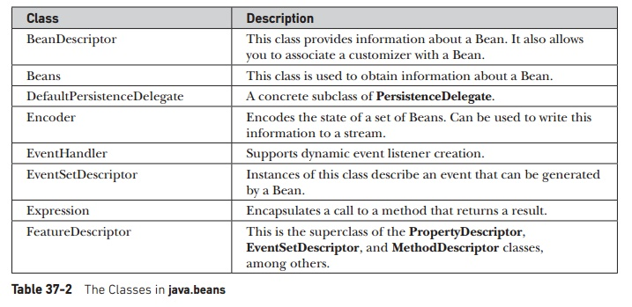
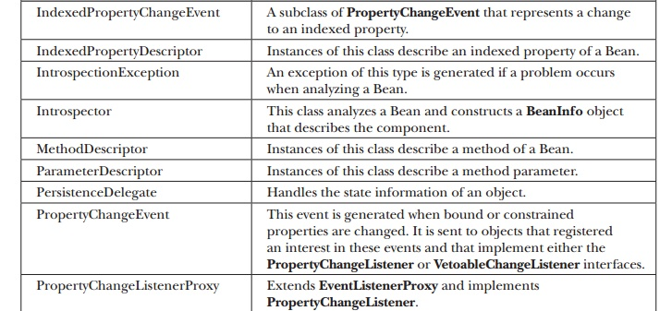
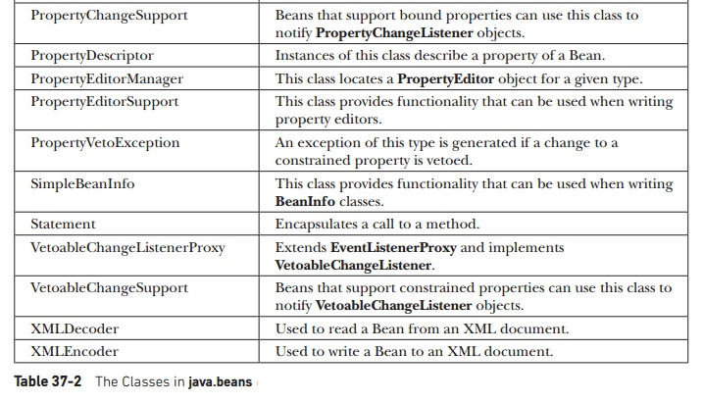

Although it is beyond the scope of this chapter to discuss all of the classes, four are of particular interest: Introspector, PropertyDescriptor, EventSetDescriptor, and MethodDescriptor.

